Filtering and Sorting
Note : Create the following dummy table in MySQL Workbench using CREATE FUNCTION-
Sample Table:
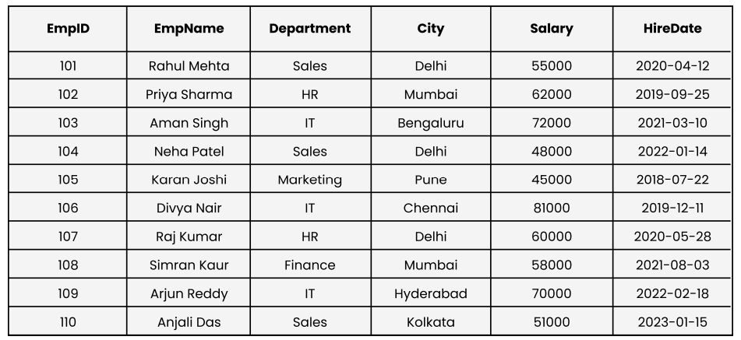
Solution : -
select * from Employees;
create table Employees(EmpID int, EmpName varchar(50), Department varchar(50), City varchar(50), Salary int, HireDate date);
insert into Employees (EmpID, EmpName, Department, City, Salary, HireDate) values (101, 'Rahul Mehta', 'Sales', 'Delhi', 55000, '2020-04-12'),
(102, 'Priya Sharma', 'HR', 'Mumbai', 62000, '2019-09-25'),(103, 'Aman Singh', 'IT', 'Bengaluru', 72000, '2021-03-10'),
(104, 'Neha Patel', 'Sales', 'Delhi', 48000, '2022-01-14'),(105, 'Karan Joshi', 'Marketing', 'Pune', 45000, '2018-07-22'),
(106, 'Divya Nair', 'IT', 'Chennai', 81000, '2019-12-11'),(107, 'Raj Kumar', 'HR', 'Delhi', 60000, '2020-05-28'),
(108, 'Simran Kaur', 'Finance', 'Mumbai', 58000, '2021-08-03'),(109, 'Arjun Reddy', 'IT', 'Hyderabad', 70000, '2022-02-18'),
(110, 'Anjali Das', 'Sales', 'Kolkata', 51000, '2023-01-15');
Question 1 : Show employees working in either the ‘IT’ or ‘HR’ departments.
Solution : -
select * from employees where Department IN('IT','HR');
Below is the result:-
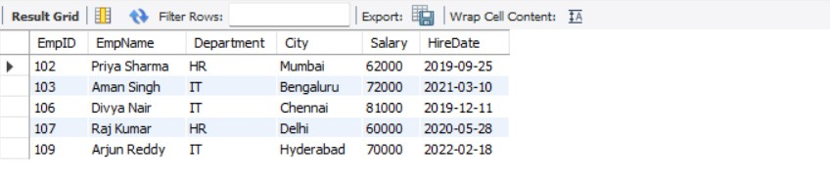
Question 2 : Retrieve employees whose department is in ‘Sales’, ‘IT’, or ‘Finance’.
Solution : -
select * FROM employees where Department IN ('Sales','IT','Finance');
Below is the result:-
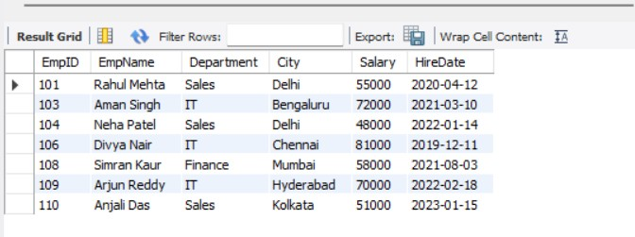
Question 3 : Display employees whose salary is between ₹50,000 and ₹70,000.
Solution : -
select * FROM employees where salary between 50000 and 70000;

Below is the result:-

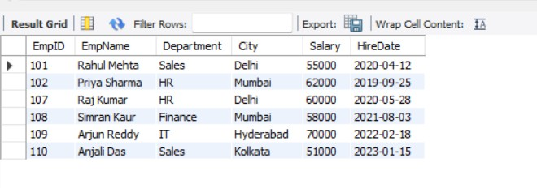

Question 4 : List employees whose names start with the letter ‘A’.
Solution : -
Select * from employees where EmpName LIKE 'A%';
Below is the result:-
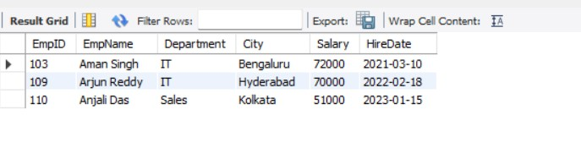

Question 5 : Find employees whose names contain the substring ‘an’.
Solution : -
Select * from employees where EmpName LIKE '%an%';
Below is the result:-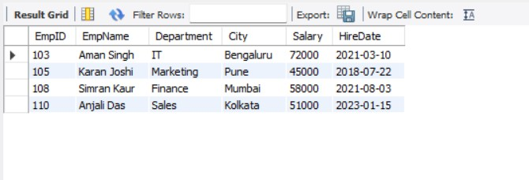

Question 6 : Show employees who are from ‘Delhi’ or ‘Mumbai’ and earn more than ₹55,000.
Solution : -
select * FROM employees where city in ('Delhi','Mumbai') and salary > 55000;
Below is the result:-
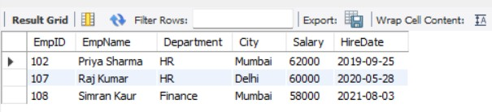

Question 7 : Display all employees except those from the ‘HR’ department.
Solution : -
select * from employees where department not in ('HR');
Below is the result:-
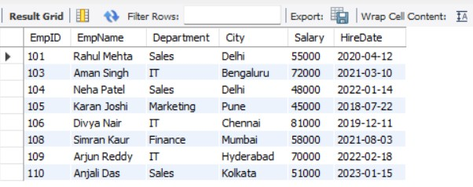

Question 8 : Get all employees hired between 2019 and 2022, ordered by HireDate (oldest first).
Solution : -
SELECT *FROM Employees WHERE HireDate BETWEEN '2019-01-01' AND '2022-12-31' ORDER BY HireDate ASC;
Below is the result:-

